**Dr. Sunil Rai**

Vice Chancellor, UPES

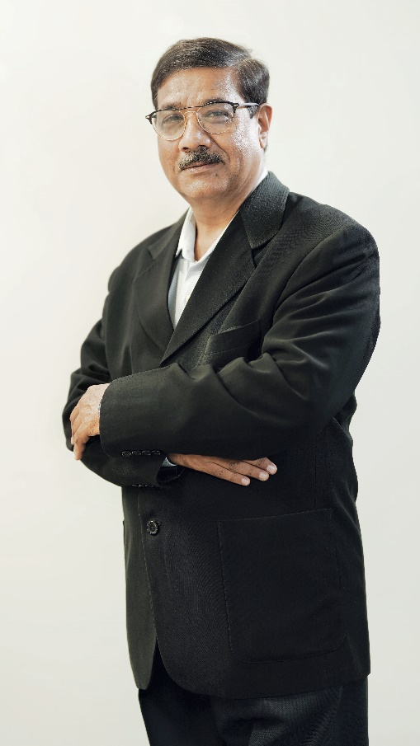Dr. Sunil Rai is the Vice Chancellor of University of Petroleum and Energy Studies (UPES). A veteran academician, he has a vast experience of 42 years with 20 years in academics, 21 years with the Indian Navy and 2 years in the corporate world. Prior to joining UPES, he was the Vice Chancellor of MIT Arts Design & Technology University, Pune and Director on Board of Maharashtra IT Corporation, Govt. of Maharashtra.

In his illustrious career in the world of academia, Dr. Rai has come to be known for designing and implementing plans that transform organisations. He has led them in various capacities - as pro-vice-chancellor, director, dean, and chairperson; additionally, he has been instrumental in building some of these universities into huge brands – through implementing processes, developing and nurturing their staff and obtaining accreditations for them.

He is also a defense veteran and managed ships and technical establishments of Indian Navy in various capacities. He was a commissioned officer in the Indian Navy for 21 years and served on ships INS Vikrant, Nilgiri, Himgiri and Oil tanker Shakti.

Dr. Rai holds a PhD in Business Continuity Management from BITS Pilani, M. Tech. in Computer Science & Engineering from IIT Mumbai and MBA with HR Specialization from IGNOU. He also holds a Masters in Marine Engineering from Naval College of Engineering (NCE), INS Shivaji – Lonavla and B.Sc. Honors degree from Jawahar Lal Nehru University (JNU), New Delhi.

An astute academician, Dr. Rai has been rated as the best faculty for eight years in succession at national and foreign campuses. He has an eclectic mix of management, engineering and performing arts as part of his professional journey and his research interests comprise of technology enabled - people driven change management and organizational development.

Dr. Rai is also a member of the Board of Advisors, Outreach Programs of Virginia Polytechnic University, Blacksburg, USA and the co-founder of Cambridge Global Partners, Edinburgh UK, which provides strategic consulting to several industrial and academic organizations.

A proven thought leader with unbridled enthusiasm for work, he has published papers on Business Continuity and Higher Education in various journals and published articles in management magazines & business, education columns in newspapers. An excellent communicator and a prolific speaker, he has addressed national & international conferences and has earned accolades for his oratorical skills and style of public speaking.